Racing Flags
Visual | Signal | Description | Flag primitive
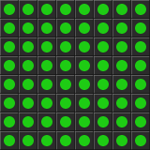 | Green flag | The green flag signals a clear track to race on. | SIMPLE
 | Red flag | The red flag means the race is stopped. | FLASHING
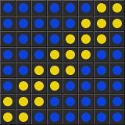 | Blue flag | This flag encourages a driver to move aside to allow faster traffic to pass. | DIAGONAL_STRIPE
 | Debris flag | The red-striped yellow flag, also known as the "surface flag", indicates a potential traction hazard. | STRIPPED
 | Yellow flag | The yellow flag means local caution. | WAVING
 | Black flag | The black flag orders a particular driver into the pit area. | INVERTED
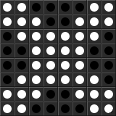 | Disqualification | This flag signals a car is no longer being scored. | CROSSED
 | Furled black flag | This flag indicates a penalty for bad conduct. | FURLED
 | Meat ball flag | This flag indicates an internal hazard in a participant's vehicle. | MEATBALL
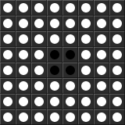 | White flag | The white flag signals that the final lap is in progress. | SIMPLE
 | Checkered flag | The chequered flag is displayed at the start/finish line to indicate that the race is officially finished. | CHECKERED

Safety Car Procedure
Visual | Signal | Description | Flag primitive
 | Full course caution flag (road) | Full course caution on road track types | SAFETYCAR
 | Full course caution flag (oval) | Full course caution on oval track types | FLASHING
 | One Lap to Green |  | INVERTED
 | Green, green, green! | The green flag signals end of the caution and restart of the race. | SIMPLE

Optional
These can be enabled or disabled in iFlag options menu.

Race Start Lights
Visual | Signal | Description | Flag primitive
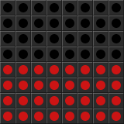 | Ready! | This represents all start lights off. | HALF
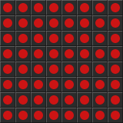 | Set! | This represents all red start lights on. | SIMPLE
 | Go, go, go! | Clearly, this represents all green start lights on. | SIMPLE

Miscelanous
These are used for various system purposes.
Visual | Signal | Description | Flag primitive
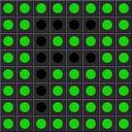 | "F flag" | Displayed as greeting on iFlag startup. It is also used as a check pattern displayed when setting board orientation in the options menu. | F
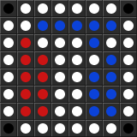 | iRacing logo | This is actually not used for anything yet.. | IRACING_LOGO

